**EVENT MANAGEMENT SYSTEM**

***Introduction :***

An event is something that takes place at a particular place and time. In keystroke programming, an event is a software message that indicates something has happened, such as a or mouse click. According to the Oxford English Dictionary, the word "manage" comes from the Italian *maneggiare* (to handle). Management has to do with power by position, whereas leadership involves power by influence.

**CERTIFICATE OF COMPLETITION**

This is certified that Waqas Ali & Daniyal **Ejaz** submitted Project entiteled “Event management System” as i-Project of ACCP.

IPRO-201605B

**INTRODUCTION**

***ABOUT THE COMPANY***

***PROBLEN STATEMENTS***

***Standards plan:-***

The problem statement is attached seperately in a file **EVENT MANAGEMENT SYSTEM.docx**

***Standards plan:-***

1. Every code block must have comments.
2. The logic of the program needs to be explained. Proper documentation should be maintained.
3. Complete Project Report along with synopsis, code and documentation should be prepared.

***Note:-***

Don’t forget to take your data backup every day. This will save your project work from the following:

a. Virus problem

b. System failure

c. File corrupt

Data Backup is an important event to be done on regular basis in a project management.

**REQUIREMENT SPECIFICATION**

1. The user must have to Login first for using application. In case of first time login a Signup panel is required which take necessary input like user id, password and age.
2. Events must be maintained Login User wise.
3. First Frame should mention 3 latest event reminders which have to come in current week (Next 7 Days).
4. Second Frame will be of Create Events

& Updating & Deleting the Events with the help of this, user can easily update time, date, event title, description etc & also can delete an event.

1. On Alarm Time, A pop-up dialog box must be appearing on the screen with the alarm buzzer tone.

**HARDWARE AND SOFTWARE REQIREMENTS**

***Hardware:-***

1. A minimum computer system that will
2. help you access all the tools in the

courses is a Pentium 166 or better

64 Megabytes of RAM or better

1. Windows 98 (or higher if possible)
2. Java Virtual Machine

***Software:-***

* Notepad/Textpad/Java editor
* j2sdk1.4.1_02 (or later) / .Net / J2EE
* JSP / Servlets
* EJB / Struts
* JDBC
* SQL Server 2000 (or later) / Oracle 9i / MS Access
* JDBC Driver

**TASK SHEET**

|  |  |  |  |  |
| --- | --- | --- | --- | --- |
| **S.NO.** | **TASK** | **TASK DURATION** | **GROUP MEMBER NAME** | **STATUS** |
| **1** | **Analysis** | **01 Days** | **Waqas Ali,**  **Daniyal Ejaz** | **Done** |
| **2** | **Design** | **05 Days** | **Waqas Ali** | **Done** |
| **3** | **Re-Design** | **02 Days** | **Waqas Ali** | **Done** |
| **4** | **Development** | **12 Days** | **Waqas Ali** | **Done** |
| **5** | **Testing** | **half Days** | **Waqas Ali, Daniyal Ejaz** | **Done** |
| **6** | **Documentation** | **Some Hours** | **Waqas Ali, Daniyal Ejaz** | **Done** |

**Waqas Ali, Daniyal Ejaz**

**Login Form**

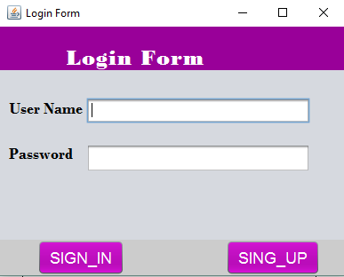

User can login from this form.

**Sign_Up Form**

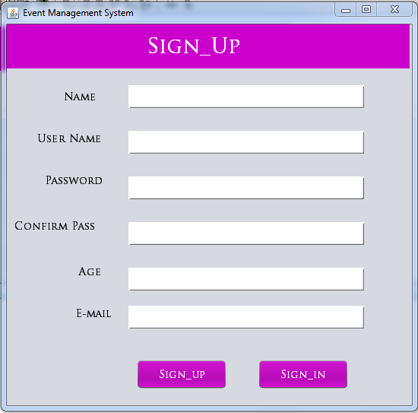

If you are not registered so you can register yourself from this form.

**Upcoming Events**

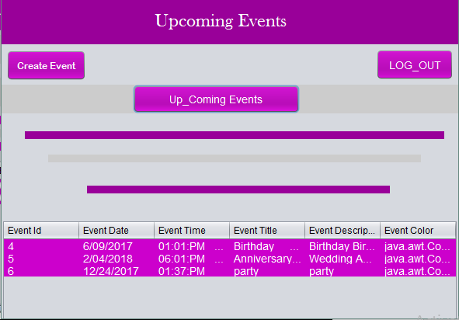

User can view 3 latest event which have to come in current week (Next 7 Days).

**Custom Events**

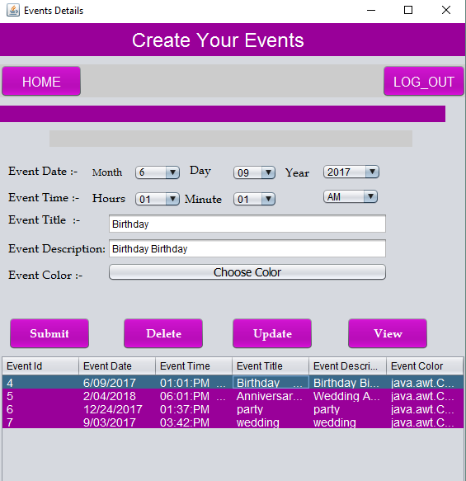

User can create,delete,update and view events from this form

**Alarm Form**

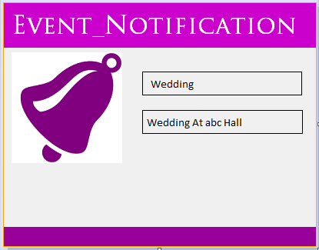

Events notification…..

This form is alert a user .